Instructions for formatting, ServDes –SDC Title, Arial 20
Authors’ names, separated by comma – leave blank for anonymous submission
contact.author@email.mail
address

Abstract
In this document we demonstrate how to use the document template for submission of papers to the ServDes conferences. Please use this document as a template and use the formatting styles that we have defined to format your document. All of our formats are described with SDC in the title. Use these styles only and not any other format styles. Your abstract should be up to 150 words.

KEYWORDS: formatting instruction, template, full papers

Introduction
The format described in this document should be used for submissions that will be published in the conference proceedings. As we want to give these proceedings as a publication a consistent, high-quality appearance, we would like to ask authors to follow some simple guidelines. Generally, you should format your paper exactly as this document is formatted. The easiest way to achieve this is to use this template and substitute the content with your own text. The template file contains specially formatted styles, all beginning with SDC that you should use, which will reduce your work with formatting your submission, and reduce the amount of time spent preparing camera ready submissions.

Page elements
The page is A4 (21cm x 29.7cm) and set with a top margin of 2 cm, a bottom margin of 2.5 cm, a left margin of 3.5 cm, and a right margin of 3.5 cm. It is a single column of 14 cm width and the height of the text area is 25.2cm. If you are using any of the formats such as Letter or Legal as your standard page size, make sure that the text area is 14 x 25.2 cm and that it’s horizontally centered and with a top margin of 2 cm.
Footers and headers should not be used for paper specific text. Never use headings directly under headings, always add text below headings.

Type set text – SDC Heading level 2, Arial 14
Use only the predefined type set. Plain text is Garamond 11pt and is called SDC Plain text. Italic text is same font and has own format name – SDC italic.
The authors should be bold and italic, Garamond 11, using SDC Author name
and the contacts should be in italic Garamond 11 – SDC Author contact details.

Keywords, SDC Keywords - Arial 10, are separated by comma.
References, SDC References – Garamond 11, should have SDC Heading level 2 as heading, and hang 0,5 cm.
- Bullet points should have 0 point space before SDC Bullet point, Garamond 11
Figures – SDC Heading level 3, Arial 10
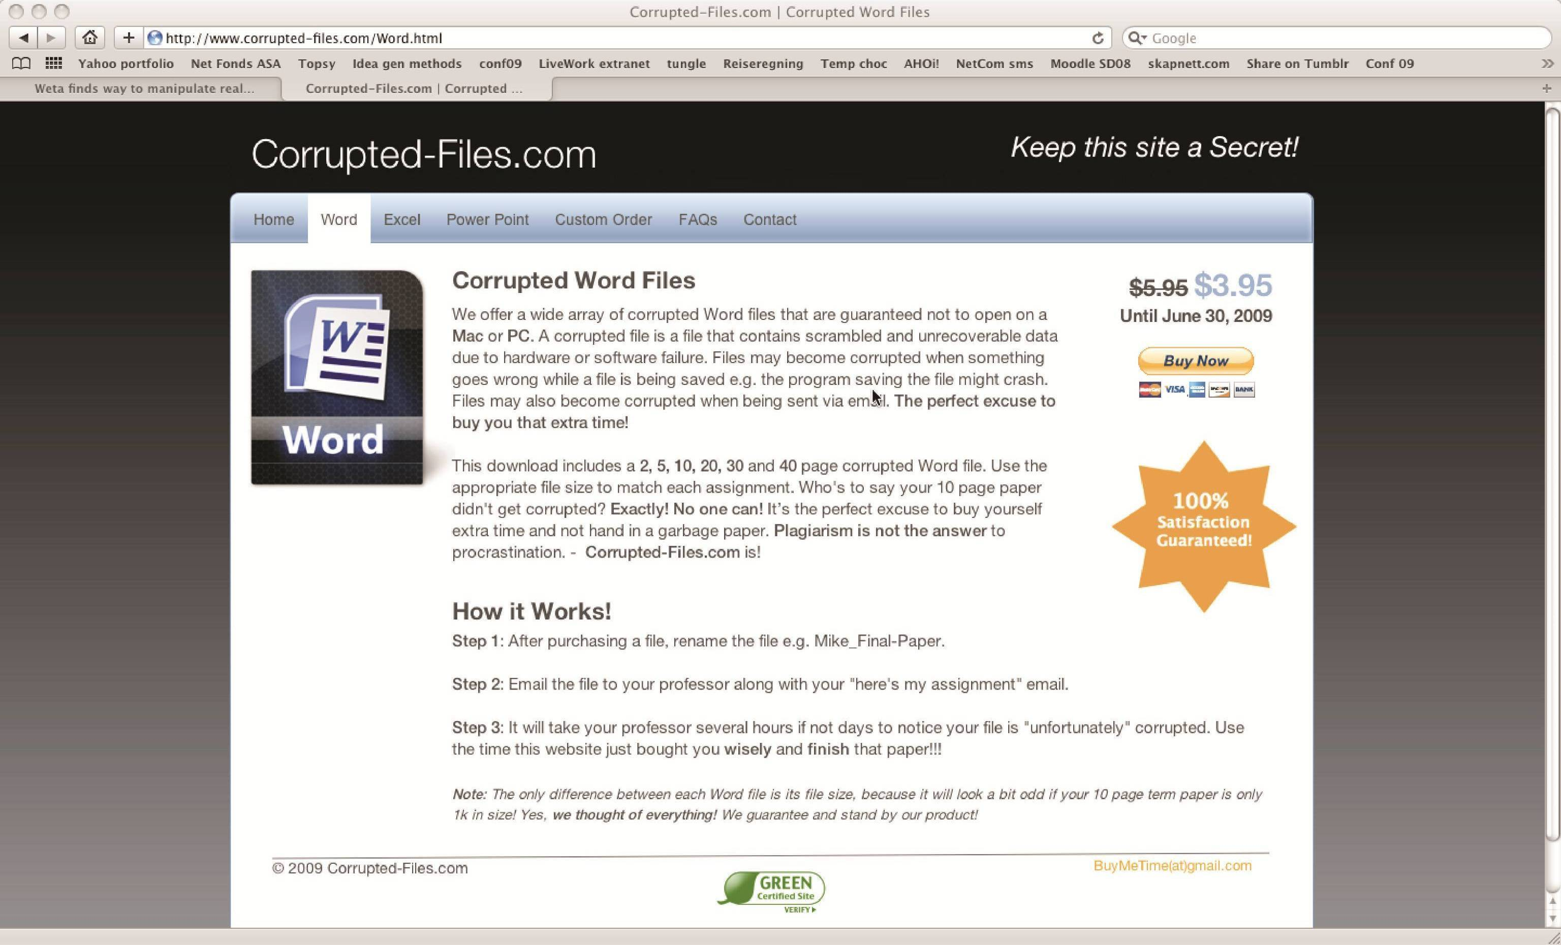
Figures must not be more than 14 cm wide and 25.2 cm high. Colour figures are allowed but might need adjustments to look alright if printed in black and white. Tables and figures should be numbered, e.g. “Table 1” or “Figure 2” and the caption should look like in Figure 1. To limit the size of the file, please use image editing tool to resize large images. We recommend a resolution around 300 dpi at most.
Figure 1 shows an example image. The caption format is SDC Caption, Cambria 10 point bold.

Title and Authors
Multiple row titles should only run over two rows.
In the anonymous submission, leave the placeholders for Authors and affiliation as they appear in this template. When preparing your final submission, all authors should be listed in the author’s row. The primary author should be the contact author and fill out contact details.

Language and style
The written language of the conference is English. Use any dialect of English, but do so consistently throughout the paper. Try using gender neutral language as much as possible and make sure to explain any culturally specific formulations and be aware not to use ambiguous terms or saying that may be unknown if you are not a native English speaker. Also try to use a simple and clear style of reasoning and avoid difficult technical terms. Show the full name before you use acronyms the first time.

References and citations
Citations as part of a sentence shows authors names in text, and year within parenthesis: e.g. as stated by Holmlid & Evenson (2007). Citations that are not part of a formal sentence, should be placed inside parenthesis: e.g. revealing patterns of human thought (Howard, 2008; Bechmann, 2010; Holmlid & Evenson, 2007) or other phenomena (Participle, 2008). If a reference is authored by one or two individuals, give both names. For three or more authors, name only the first one followed by et al.. Try using only sources you have personally read or make sure it is clear that you are referring to a second hand source.
Quotations should be part of the normal text flow and include page numbers when possible; e.g. “… a crucial dimension to use to increase understanding and the role of prototyping is at what stage in the generic service design process a prototyping method is used.” (Holmlid & Evenson, 2007, p. 6). For quotations longer than two rows, they should be in a paragraph of their own and use the SDC quote style:
Beveridge was a 20TH century giant. The vision and strategy he set out in his first 1942 report were supported by political thinkers on the left and right, and by the general public who wanted a new and fairer Britain. Before Beveridge, Britain can be seen as a place of gross inequality, with health care that few could afford or find, schools which looked like those portrayed in a Dickens’ novel, and a society desperately hanging on to its colonial legacy. The post-war welfare state swept all this away in one of the most dramatic social transformations Britain has ever seen. (Particple, 2008, p. 2)
References should be made like in the examples below. If the sources are in another language than English you should provide a translation of the title and source.

References
Example references. Note that for the review no references to submitting authors should be included.

Bechmann, S. (2010). Servicedesign. Århus: Academica.
Holmlid, S., & Evenson, S. (2007). Prototyping and enacting services: Lessons learned from human-centered methods. Proceedings from the 10th Quality in Services conference, QUIS 10. Orlando, Florida.
Howard, J. (2008, 03 19). Service Recovery. Retrieved 03 22, 2010, from Design for Service: http://designforservice.wordpress.com/2008/03/19/service-recovery/
Participle. (2008). Beveridge 4.0. London: Participle Limited.

